**16 bit division:**

**Code:**

lhld 2001

xchg

lhld 2020

mov a, d

mov b, h

mvi c,00h

loop: inr c

sub b

jnz loop

mov h, c

mov a, e

mov b, l

mvi c,00h

lp: inr c

sub b

jnz lp

mov l, c

shld 2050

hlt

**OUTPUT:**

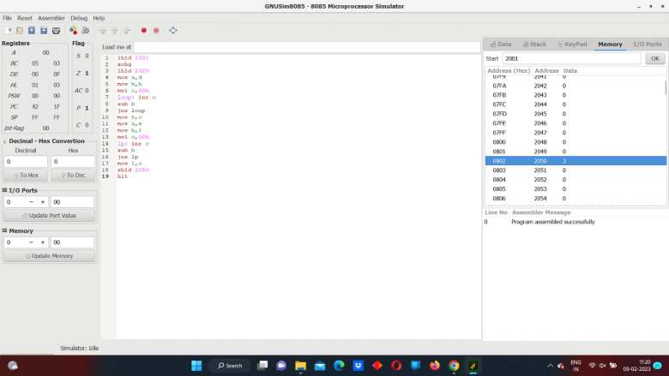sss